SRM IST Date : 14.09.2022 , Batch 2 Set A
Department of Electrical and Electronics Engineering
Cycle Test 1 – 18EEO301T – Sustainable Energy

Part A

1. In India the standard meridian cross the -------
(a) Delhi
(b) Culcutta
(c)Mumbai
(d) Alagabhat
Answer (d)
2. What is the most common material used in making solar cells?
(a) Silver
(b) Iron
(c) Aluminium
(d) Silicon
d
3. Diffused radiation
(a) Has no unique direction
(b) Has a unique direction
(c) Has short wavelength as compared to beam radiation
(d) Has large magnitude as compared to beam radiation.
Answer (a)
4. Terrestrial radiation has a wavelength in the range of----micrometer.
(a) 0.2 to 4
(b) 0.2 to 0.5
(c) 0.380 to 0.760
(d) 0.29 to 2.3
Answer (a)
5. The percentage of the incoming radiation reflected back to space by the earth is
(a) 10 %
(b) 20 %
(c) 30 %
(d) 40 %
Answer (c)

Part B
6. Write the advantages of solar energy.
Eco friendly , available in abundance, free of cost.
7. Draw the IV characteristics of Solar PV
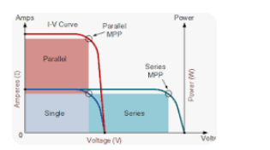
8. Write the various types of Phyheliometer.
Silver- disc pyrheliometer, water-flow pyrheliometer, Eppley pyrheliometer, spectropyrheliometer, Michaelson actinograph.

9. Define Solar still.
A solar still distills water with substances dissolved in it by using the heat of the Sun to evaporate water so that it may be cooled and collected,.

10. Define sunshine recorder.

A sunshine recorder is a meteorological instrument used for recording the amount of sunlight that a particular location receives throughout a day.

Part C

11.
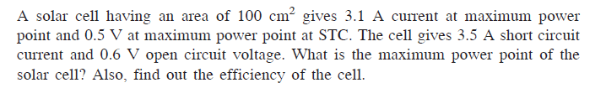

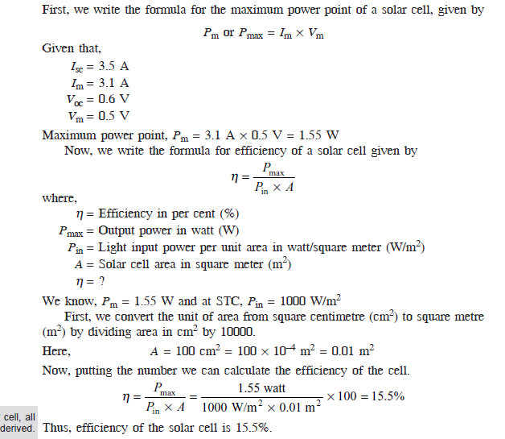

(or)

12.
What is MPPT and write the various types of MPPT techniques .

Any improvement in the rise time of MPPT improves the reliability of the system and increases the power extraction and efficiency of the whole system.

1. Perturbation and Observation (P&O)
2. Incremental Conductance (IncCond)
3. Constant voltage method
4. Constant current method

SRM IST Date : 14.09.2022 , Batch 2 Set B
Department of Electrical and Electronics Engineering
Cycle Test 1 – 18EEO301T – Sustainable Energy

Part A

1. A horizontal surface receives
(a) No reflected component of radiation
(b) 50 % of the reflected component of radiation
(c) 50% of the diffused component of radiation
(d) 50% of the beam component of radiation.
Answer (a)
2. At solar noon, the hour angle is
(a) +90
(b) -90
(c) Zero
(d) +180
Answer (c)
3 .The significance of the Lattitude is
(a)To Identify a exact location of a place
(b) to determine the Temperature of the region
(c)to find the Timing of the region
(d)to forcast the Rain fall of the region
Answer (b)
4. The significance of the Longitude is
(a) to identify a exact location of a place
(b) to determine the Temperature of the region
(c) to find the Timing of the region
(d) to forecast the Rain fall of the region
Answer (c)
5. Diffused radiation
Has no unique direction
Has a unique direction
Has short wavelength as compared to beam radiation
Has larger magnitude as compared to beam radiation
A

Part B
6. Write the various types of pyranometer.
Eppley pyranometer, Yellot solarimeter, Moll – Gorczyheski solarimeter, Bimetallic action graphs of the Rabitzsch type, Volochme pyranometer, Thermoelectric Pyranometer.

7. Write any 3 disadvantages of solar PV.
Non reliable source, initial cost is more; need a storage device to store the energy for stand alone systems.

8. Draw the Power vs Voltage characteristics of solar Photovoltaic.
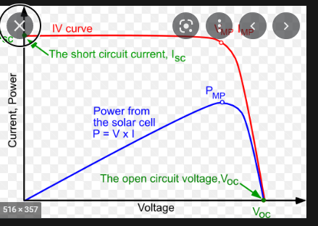
9. Write the types of solar pv cells.
Monocrystalline silicon, polycrystalline silicon, and thin film
10. What is solar passive heater?
Passive solar heating systems capture sunlight using flat plate collect and with the thermo shipon concept the heated water goes up and collected.

Part C

11.
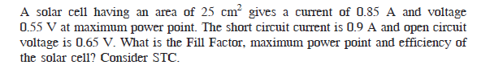

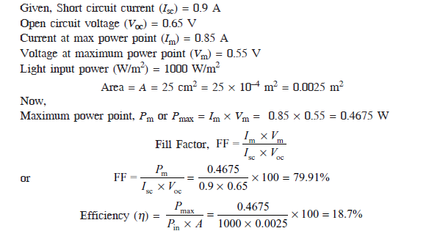
(or)

12.
Explain the various angles with the necessary diagram to calculate the incidence angle.

Tilt angle, azimuth angle, hour angle, declination angle, solar altitude angle.

SRM IST Date : 14.09.2022 - Batch 2 Set C
Department of Electrical and Electronics Engineering
Cycle Test 1 – 18EEO301T – Sustainable Energy

Part A

1.What is the standard value of solar constant in kW/Square meter
A.1
B.1.367
C.1.5
D.5
B
2. When incoming solar radiation passes through the atmosphere of the earth
A.Radiation of all wavelengths is absorbed uniformly by different types of molecules
B.Different molecules selectivity absorbs the radiation of different wavelengths
C.There is no absorption of radiation in the atmosphere
D.There is total absorption of radiation
b
3.
Air mass ratio is minimum
A.When the sun is at zenith
B.At sun rise
C.At sun set
D.At 6.00 GMT
A
4. Solar radiation flux is usually measured with the help of a
A. Anemometer
B. Pyranometer
C. Sunshine recorder
D. pulse meter
Answer: B.Pyranometer
5.The scattered solar radiation is called ____________
A. Direct Radiation
B. Beam Radiation
C. Diffuse radiation
D. Infrared Radiation
Answer: C. Diffuse radiation

Part B
6. What is solar active heater?
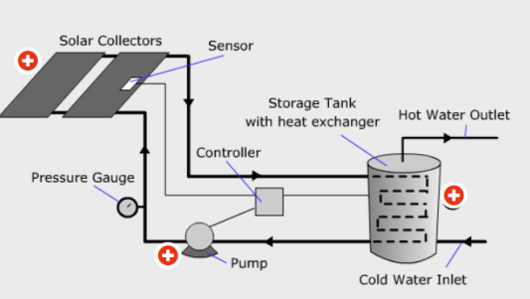
Active solar heating systems are comprised of collectors, a distribution system, and a storage device.

7. Write about solar desalination.
Solar desalination is a technique to desalinate water using solar energy.

8. Define net metering concept.
Net metering refers to a mechanism whereby solar energy exported to the grid from grid-tied rooftop solar PV system of a prosumer is deducted from the energy imported from the grid in units (kilowatt-hours) to arrive at the net imported / exported energy.

9. Define solar cooker.
A solar cooker is a device which uses the energy of direct sunlight to heat, cook or pasteurize drink and other food materials.
10. What is solar heating of the building?
Solar heating, the use of sunlight to heat water or air in buildings. There are two types of solar heating, passive and active. Passive heating relies on architectural design to heat buildings.

Part C

11.
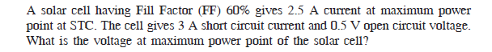

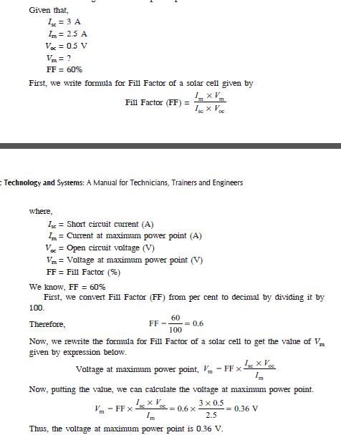
(or)

12.
Explain in detail with the necessary diagrams for solar power generation.
